Картина, която съдържа текст

Описанието е генерирано автоматично

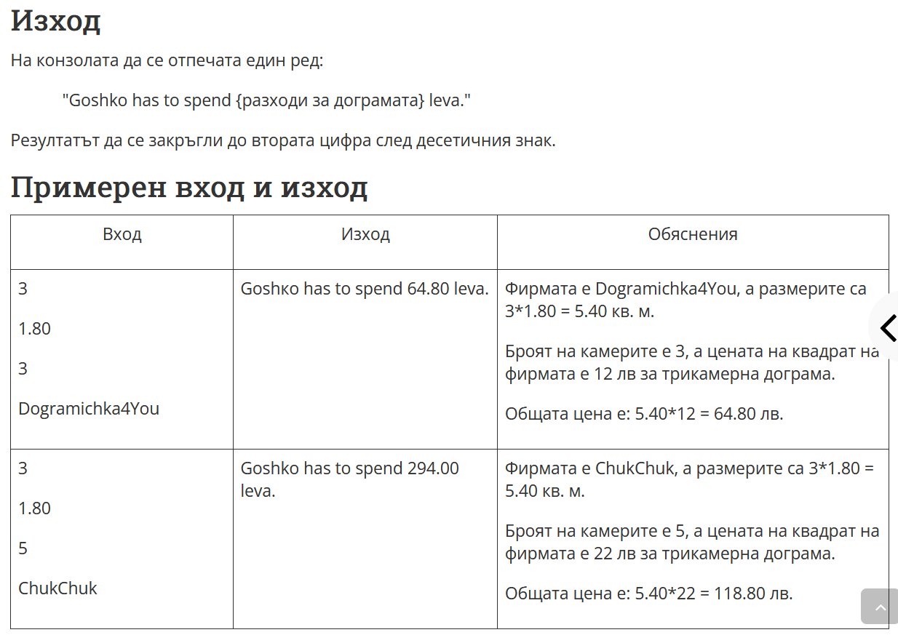

Решение на 3 задача

using System;

namespace Rhombus_of_Stars

{

class Program

{

static void Main(string[] args)

{

var width = double.Parse(Console.ReadLine());

var lenght = double.Parse(Console.ReadLine());

var kameras = int.Parse(Console.ReadLine());

var name = Console.ReadLine();

if (width >= 0 && width <= 999)

{

if (lenght >= 0 && lenght <= 999)

{

if (kameras >= 3 && kameras <=5)

{

// zapo4wa zada4ata

if ( kameras == 3)

{

if (name == "Dogramichka4You" )

{

var price = 12;

double area = width * lenght;

double priceFinal = Math.Round(area * price, 2);

Console.WriteLine($"Goshko has to spend {priceFinal:F2} leva" );

}

else if (name == "TihoToplo")

{

var price = 15;

double area = width * lenght;

double priceFinal = Math.Round(area * price, 2);

Console.WriteLine($"Goshko has to spend {priceFinal:F2} leva");

}

else if (name == "ChukChuk")

{

var price = 14;

double area = width * lenght;

double priceFinal = Math.Round(area * price, 2);

Console.WriteLine($"Goshko has to spend {priceFinal:F2} leva");

}

}

else if (kameras == 4)

{

if (name == "Dogramichka4You")

{

var price = 15;

double area = width * lenght;

double priceFinal = Math.Round(area * price, 2);

Console.WriteLine($"Goshko has to spend {priceFinal:F2} leva");

}

else if (name == "TihoToplo")

{

var price = 14;

double area = width * lenght;

double priceFinal = Math.Round(area * price, 2);

Console.WriteLine($"Goshko has to spend {priceFinal:F2} leva");

}

else if (name == "ChukChuk")

{

var price = 20;

double area = width * lenght;

double priceFinal = Math.Round(area * price, 2);

Console.WriteLine($"Goshko has to spend {priceFinal:F2} leva");

}

}

else if (kameras == 5)

{

if (name == "Dogramichka4You")

{

var price = 20;

double area = width * lenght;

double priceFinal = Math.Round(area * price, 2);

Console.WriteLine($"Goshko has to spend {priceFinal:F2} leva");

}

else if (name == "TihoToplo")

{

var price = 18;

double area = width * lenght;

double priceFinal = Math.Round(area * price, 2);

Console.WriteLine($"Goshko has to spend {priceFinal:F2} leva");

}

else if (name == "ChukChuk")

{

var price = 22;

double area = width * lenght;

double priceFinal = Math.Round(area * price, 2);

Console.WriteLine($"Goshko has to spend {priceFinal:F2} leva");

}

}

}

}

}

}

}

}